

Mohammad Ali Jinnah University

Chartered by Government of Sindh - Recognized by HEC

**Lab Task 4**

**Name:** Muhamad Fahad

**Id:** FA19-BSSE-0014

**Subject:** Data Structures and Algorithms Lab (CS 2511)

**Lab Title:** Insertion & Selection Sort

**Section:** AM

**Teacher:** MUHAMMAD MUBASHIR KHAN

**Date:** Thursday, November 5, 2020

**1) Implement Insertion sort on following array [5,6,1,1,8,9,3,5].**

**Code:**

import java.util.Arrays;  
public class Main {  
 public static void main(String[] args) {  
 int array[] = {5,6,1,1,8,9,3,5};  
  
  
 Sorting ob = new Sorting();  
 ob.SelectionSorting(array);  
 ob.InsertionSorting(array);  
 }  
}  
class Sorting{  
  
 void InsertionSorting(int arr[]) {  
 int length = arr.length,  
 countloop = 0;  
 System.*out*.println("----------------------------------------- Insertion Sorting ----------------------------------------- ");  
 System.*out*.println(Arrays.*toString*(arr));  
  
 for (int i = 1; i < (length); ++i) {  
 int key = arr[i];  
 int j = i - 1;  
 while (j >= 0 && arr[j] > key) {  
 System.*out*.println("j = "+j+",key = "+key+",Check("+arr[j]+"<"+key+") => "+(j >= 0 && arr[j] > key));  
 arr[j + 1] = arr[j];  
 j = j - 1;  
 countloop++;  
 }  
 arr[j + 1] = key;  
 System.*out*.println(Arrays.*toString*(arr));  
 System.*out*.println("----------------------------------------- i = " + i + " Complete -----------------------------------------");  
  
 }  
 System.*out*.println("Number of time value inner loop works: "+countloop);  
 }

}

***Output:***

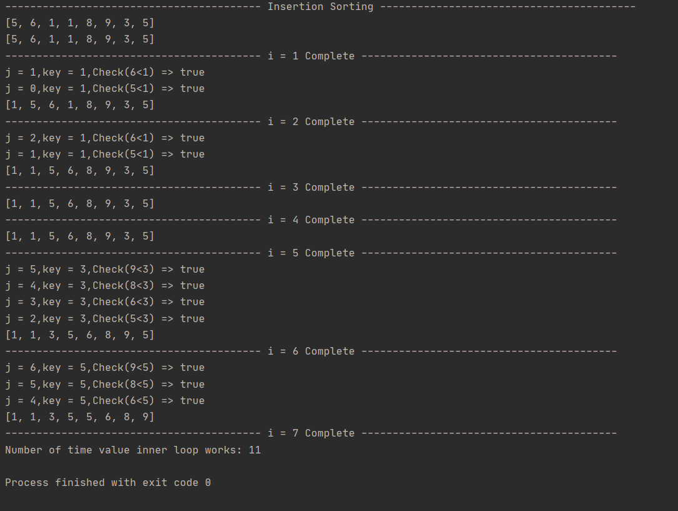

2) Implement Selection sort on following array [5,6,1,1,8,9,3,5].

**Code:**

import java.util.Arrays;  
public class Main {  
 public static void main(String[] args) {  
 int array[] = {5,6,1,1,8,9,3,5};  
  
 Sorting ob = new Sorting();  
 ob.SelectionSorting(array);  
 }  
}  
class Sorting{  
  
 void SelectionSorting(int arr[]){  
 int length = arr.length,  
 swap,  
 countloop = 0;  
 System.*out*.println("----------------------------------------- Selection Sorting ----------------------------------------- ");  
 System.*out*.println(Arrays.*toString*(arr));  
  
 for (int i = 0; i < (length-1); i++) {  
 int minIndex = i;  
 for (int j = i+1; j < length; j++) {  
 System.*out*.println("j = "+j+",minIndex = "+minIndex+",minValue = "+arr[minIndex]+",Check("+arr[j]+"<"+arr[minIndex]+") => "+(arr[j] < arr[minIndex]));  
 if (arr[j] < arr[minIndex]) {  
 minIndex = j;  
 }  
 countloop++;  
 }  
 swap = arr[minIndex];  
 arr[minIndex] = arr[i];  
 arr[i] = swap;  
 System.*out*.println("----------------------------------------- i = "+i+" Complete -----------------------------------------");  
 System.*out*.println(Arrays.*toString*(arr));  
  
 }  
  
 System.*out*.println("Number of time value inner loop works: "+countloop);  
 }

***Output:***

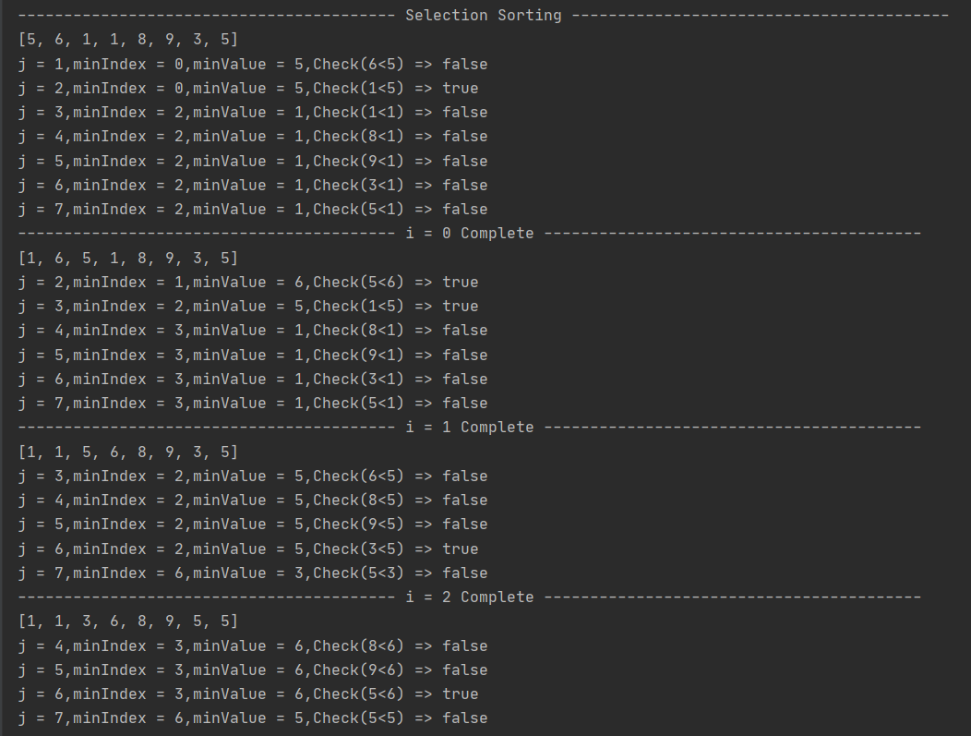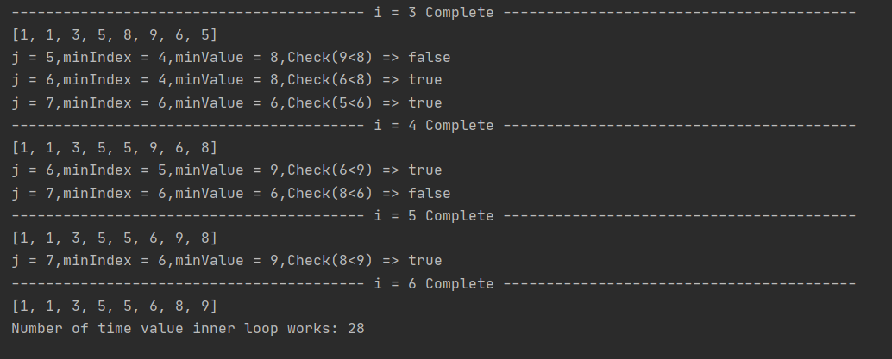

3) Which sorting technique is better for the above array.

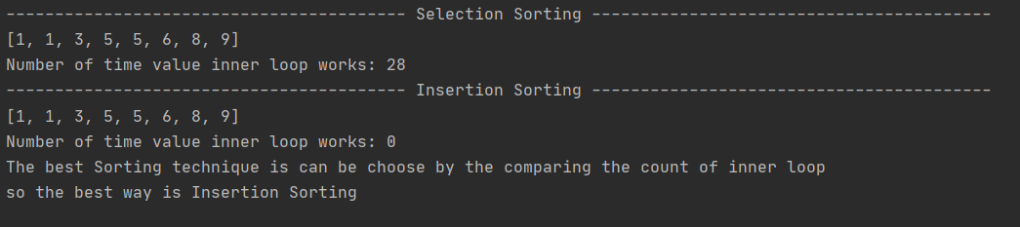

4) In what type of scenarios we should use insertion sort and selection sort.

Insertion sort is the best way for short array or small array and the array which is half sort or only one index is have be sort so the best way thing is that it will only compare one’s and the time complexity 0(n2).The best scenarios for selection sort is large data and after doing some iteration we known that the loop will not go back and found the next/least minimum from the last one so time complexity is 0(n2). The best time is O(n) and it always change/sort the position of one element in the array.